# MANAV RACHNA UNIVERSITY

Department of CST

(Software Engineering Lab– CSH207B-P)

## (Lab 0)

## HARSH MITTAL

## 2K19CSUN01082

## CSE4B

**Learning Outcomes:** Students will be able to understand how to design the database of a software system.

1. Write problem statement for library Management system.
2. Write problem statement for result Management system.

### 1.Problem Statement for Library Management System:

A software is to be developed for automating a college library. The system should be user friendly and easy to use.

1. Issue and return of books:
2. A member should be able to issue books.
3. Each member can issue a maximum of 5 books.
4. Course books can be issued for a semester and general books can be issued for 15 days.
5. The software takes the current system date as the date of issue and calculates the date of return.
6. The book can be returned within the given time period.
7. Student can renew book return date within the existing time period of return date.
8. Members should be able to reserve books that are not currently available.
9. Searching of books:
10. By book title.
11. By author name.
12. By subject name.
13. By publication.
14. Updating data:
15. Addition of new books.
16. Removal of books.
17. Edit book info.
18. Registration of new account-for students and faculty.
19. Issuing of library card.(Only librarian)
20. Removal of accounts.(Only librarian)
21. Updation of account: Librarian can update all the accounts, students and faculty can onlu ypdate their personal account.
22. Fine:
23. Late fine is levied on student or faculty if book is returned after due date.
24. If a member loses the book, fine is imposed.

### 2.Problem Statement for Result Management System:

A software is to be developed for result management system. The system should be user friendly and easy to use.

1. Upload/Update data:

* Data entry operator and teachers will have right to upload or update student result data.
* Data entry operator will be responsible to maintain student record and information.
* Data entry operator will also be responsible to maintain semester and subjects data.
* Faculty can update/upload/edit the result.
* Admin can also update result.

1. View Data:

* Students can view their result.(Pass/Fail)
* Students can view their marks.

1. Account management:

* Admin can create user account.
* Admin can modify/edit user account.
* Admin can delete user account.
* Admin can generate results.
* Admin can reset system.
* Admin can give and withdraw access from users.

## (Lab 1)

**Learning Outcomes:** Students will be able to understand how to design the database of a software system.

* 1. Draw the use case diagram for library Management system. 2.Draw the use case diagram for Result Management System.

### Use case for Library Management System:

|  |
| --- |
| Search |
| Login/Logout |
| Issue book |
| Return book |
| Renew Book |
| View account |
| Reserve book |
| Remove reservation |
| Register new account |
| Issue library card |
| Add book |
| Remove book |
| Edit book info |

Student/Faculty

Librarian

### Use case diagram for Result Management System:

**Student**

**Teacher**

**Admin**

|  |
| --- |
| Login |
| View Personal Information |
| Change Password |
| View Academic records |
| Update Results |
| Maintain user accounts |
| Reset Sytem |
| Generate reports |
| Maintain semester/subjects information |
| Maintain user info |
| Maintain result |

**Data Entry Operator**

(Lab 2)

**Learning Outcomes:** Students will be able to understand how to design the database of a software system.

* 1. Draw the E-R diagram for library Management system. 2.Draw the E-R diagram for Result Management System.

### ER Diagram for Library Management System:

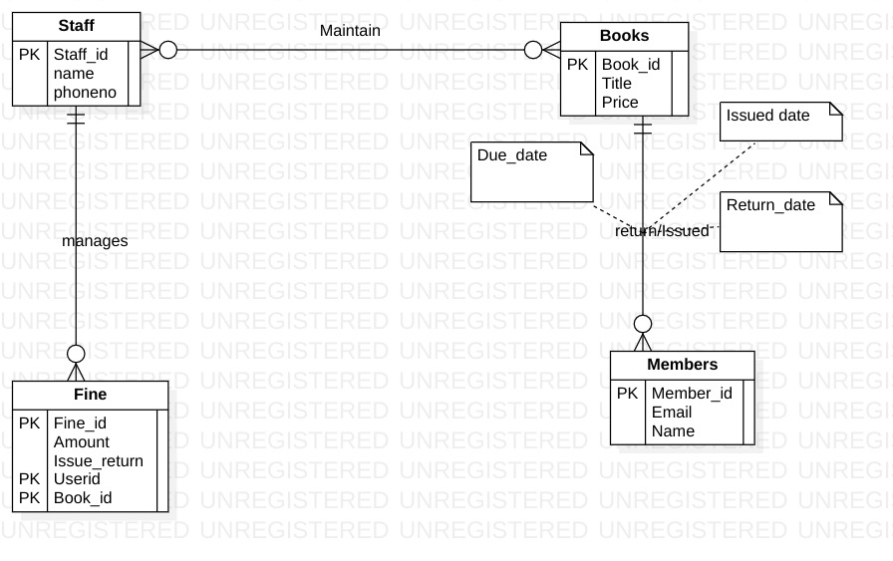

### ER Diagram for Result Management System:

